PREDICTIONS & BUSINESS INSIGHTS REPORT
LA Fitness Expansion Strategy
Regression Results, Scenario Pricing, and Florida Market Priorities
All 67 Florida counties | Census + Google Places + official gym pricing | OLS regression
Prepared for the MSIS Data Science Assignment | September 1, 2026

Observed demographics, locations, and official advertised price observations; transparent estimates only where no local offer was available

Executive Summary
The analysis combines observed Census demographics, 428 Google Places records across 67 Florida counties, and official advertised recurring price observations. Thirty-two counties have local public price observations; the remaining 35 use an explicitly labeled statewide-median estimate. The full six-variable OLS model explains 35.8% of variation in the price target; the refined three-variable model has adjusted R-squared of 0.261.
Recommendation: Prioritize validation in St. Johns County, Santa Rosa County, Hillsborough County, Collier County, Lee County. These are screening priorities, not final real-estate decisions.

Decision boundary: The price target uses official local advertised offers in 32 counties and transparent statewide-median estimates in 35 counties. Advertised prices are not transaction prices, and plan/franchise differences limit comparability. Do not commit capital until actual club pricing, leases, trade-area demographics, traffic, and competitor capacity are validated.

Data and Modeling Approach
- Unit of analysis: one row per Florida county (n = 67).
- Dependent variable: advertised/estimated monthly MembershipPrice target in U.S. dollars.
- Independent variables: population, LA Fitness count, competitor count, household income, density, and average rating.
- Observed location data: 428 Google Places records with gym names, formatted street addresses, coordinates, ratings, and review counts; exact-county filtered and deduplicated by Place ID.
- Estimation method: Ordinary Least Squares using Python statsmodels.
Price methodology: the long-form pricing file preserves official plan-level dues, billing frequency, initiation fees, annual fees, promotions, source URLs, and retrieval timestamps for LA Fitness, Planet Fitness, YouFit, Gold's Gym, and Orangetheory Fitness.
For the county target, one lowest recurring advertised offer was selected per observed local club and averaged within county. Thirty-two counties have local observations; 35 counties use the statewide median of 232 retained local club offers ($43.99). Planet Fitness published starting rates are real but chainwide, so they are not assigned to counties. No predictor-based or random synthetic formula is used.

Full OLS Model
Metric | Full model | Refined model
R-squared | 0.358 | 0.295
Adjusted R-squared | 0.294 | 0.261
AIC | 494.37 | 494.70
BIC | 509.80 | 503.52
RMSE (USD) | $8.72 | $9.14

Variable | Coefficient | p-value | 95% confidence interval
Intercept | -22.157140 | 0.507 | [-88.551090, 44.236811]
CountyPopulation | 0.000029 | 0.006 | [0.000009, 0.000050]
LAFitnessLocations | -4.378677 | 0.00047 | [-6.745161, -2.012193]
CompetitorLocations | -0.349934 | 0.517 | [-1.423008, 0.723140]
MedianHouseholdIncome | 0.000259 | 0.016 | [0.000049, 0.000468]
PopulationDensity | 0.004876 | 0.110 | [-0.001139, 0.010890]
AvgGymRating | 12.124557 | 0.110 | [-2.810206, 27.059319]

Multicollinearity
Variable | VIF | VIF > 5 assessment
CountyPopulation | 20.42 | Concern
LAFitnessLocations | 11.18 | Concern
CompetitorLocations | 17.64 | Concern
MedianHouseholdIncome | 1.19 | Acceptable
PopulationDensity | 2.31 | Acceptable
AvgGymRating | 1.06 | Acceptable

The highest VIF is 20.42 for CountyPopulation. Values above 5 are flagged because correlated market-size measures can make individual coefficients unstable even when overall fit is useful.

Refined Model
Backward elimination removed CompetitorLocations (p = 0.517), AvgGymRating (p = 0.108), and PopulationDensity (p = 0.097). The refined model retains CountyPopulation, LAFitnessLocations, and MedianHouseholdIncome. This mechanical rule is used for the assignment demonstration; real strategy work should also preserve variables supported by business theory.
Variable | Coefficient | p-value | 95% confidence interval
Intercept | 29.984351 | 0.00000 | [18.471561, 41.497142]
CountyPopulation | 0.000025 | 0.001 | [0.000011, 0.000040]
LAFitnessLocations | -4.232158 | 0.00040 | [-6.494040, -1.970276]
MedianHouseholdIncome | 0.000305 | 0.005 | [0.000096, 0.000514]

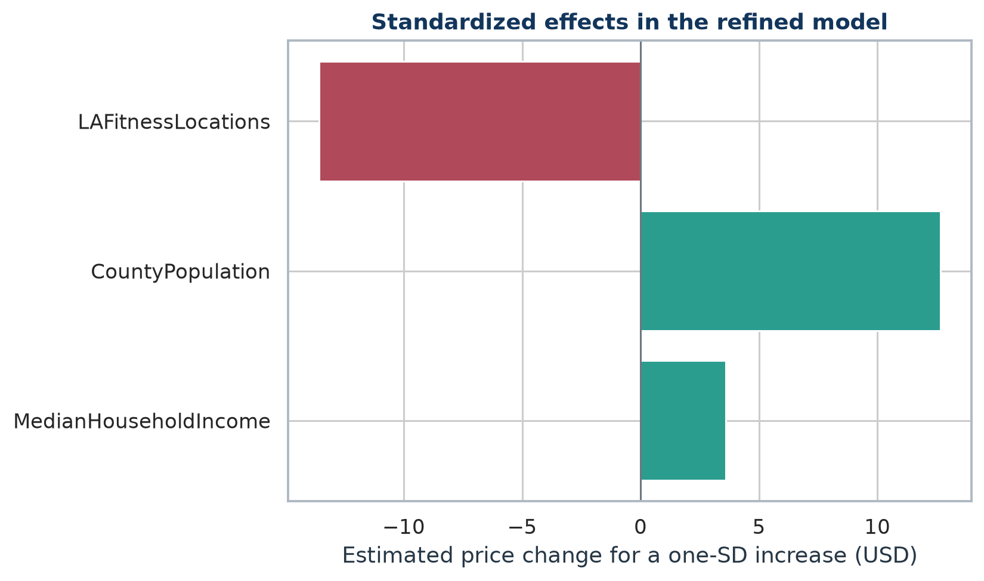
Figure 1. Refined-model price effect associated with a one-standard-deviation increase in each retained predictor.

Interpretation
- Strongest retained factor: LAFitnessLocations has the largest absolute one-standard-deviation association (-$13.57; p = 0.0004). This is an association with the price target, not evidence that opening or closing a club causes prices to change.
- Competition: the full-model coefficient is -$0.350 per additional tracked competitor (p = 0.517). It was removed during refinement, so the analysis does not establish an independent competition effect after controlling for the other predictors.
- All interpretations are associations within a target that combines local official advertised offers and transparent statewide-median estimates, not causal effects on prices or expansion success.

Model Diagnostics
Diagnostic test | Statistic | p-value | Interpretation
Shapiro-Wilk residual normality | 0.899 | 0.00005 | Residual normality concern
Breusch-Pagan homoscedasticity | 5.951 | 0.114 | No evidence of heteroscedasticity
Breusch-Pagan F version | 2.047 | 0.116 | No evidence of heteroscedasticity

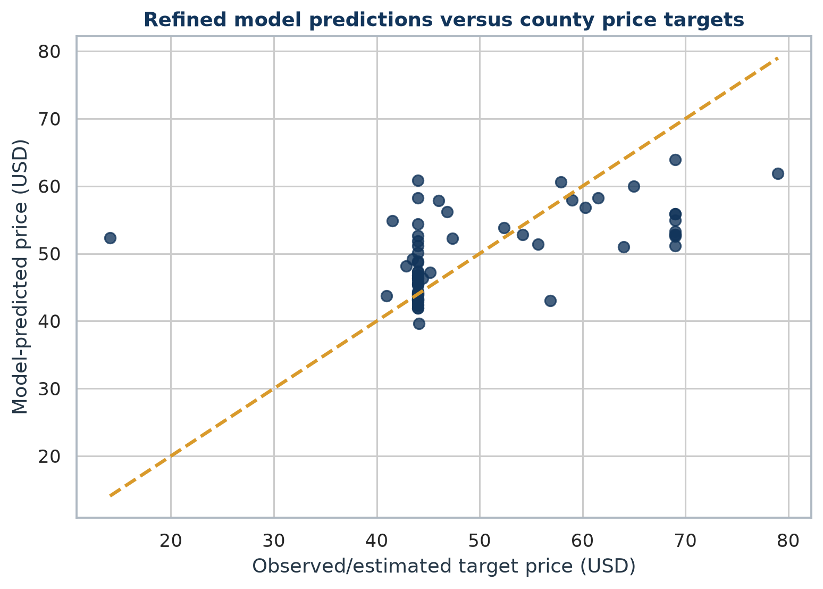
Figure 2. Observed/estimated county price targets versus refined-model predictions.
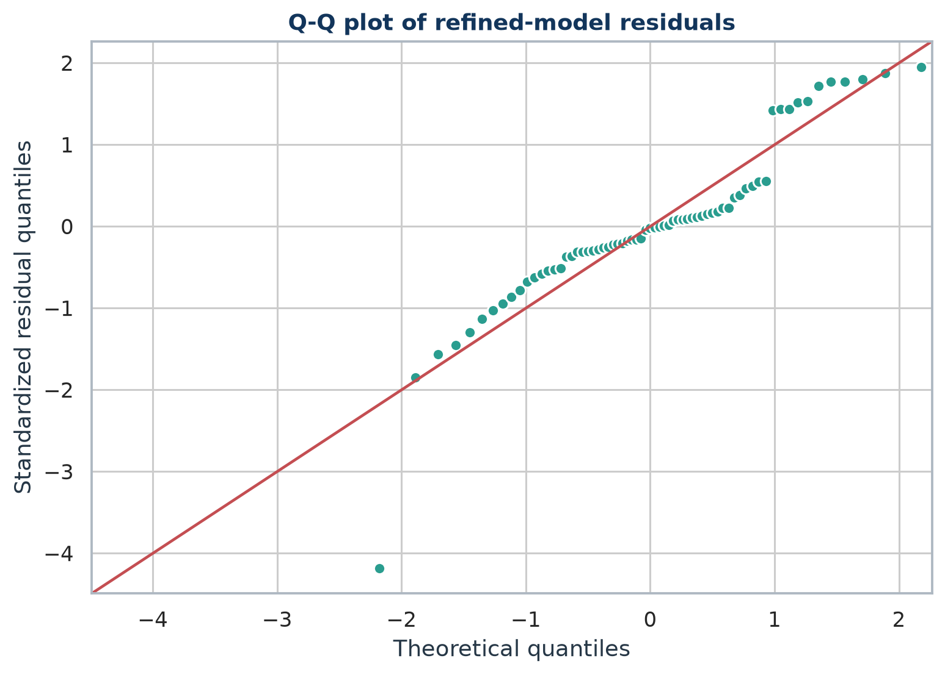
Figure 3. Q-Q plot of refined-model residuals.
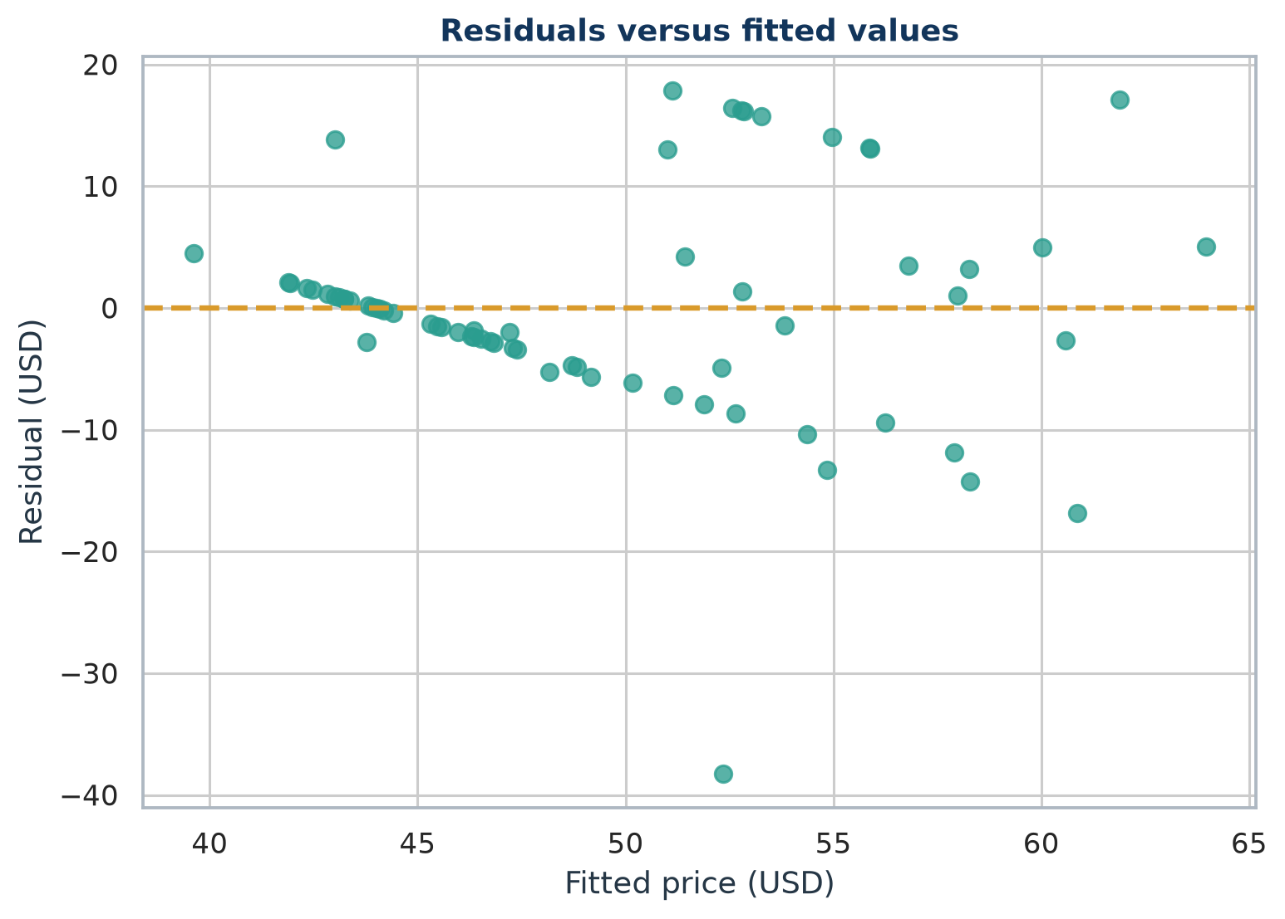
Figure 4. Refined-model residuals versus fitted values.

Influential Observations
County | Studentized residual | Cook's distance | Leverage
Polk County | -1.98 | 0.154 | 0.142
Pasco County | 1.99 | 0.142 | 0.130
Charlotte County | -4.75 | 0.086 | 0.020
Miami-Dade County | -0.71 | 0.082 | 0.389

Scenario Predictions
Each scenario supplies every variable in the original full model. Predictions use the refined model and are extrapolations from a 67-county dataset whose price target is partly estimated. The mean confidence interval describes uncertainty in the expected county price; the wider prediction interval describes uncertainty for a single comparable county outcome.
Scenario | Predicted price | 95% mean CI | 95% prediction interval
A - Rural, low competition | $41.68 | $35.43 - $47.93 | $21.82 - $61.53
B - Miami-Dade, high competition | $49.82 | $38.53 - $61.11 | $27.85 - $71.79
C - Target market: St. Johns County | $63.95 | $56.63 - $71.28 | $43.74 - $84.17

A - Rural, low competition
Population 50,000; LA Fitness locations 2; competitors 1; median household income $62,000; density 120.0 per square mile; average rating 4.20.

B - Miami-Dade, high competition
Population 2,600,000; LA Fitness locations 15; competitors 30; median household income $57,815; density 1,422.1 per square mile; average rating 4.28.

C - Target market: St. Johns County
Population 273,425; LA Fitness locations 0; competitors 4; median household income $88,794; density 455.2 per square mile; average rating 4.65.

Expansion Recommendations
The market-potential score is a transparent screening index calculated within this 67-county dataset. Weights are 30% demand (log population), 25% purchasing power, 20% low competitor intensity, 15% predicted price, and 10% low LA Fitness intensity. Components are min-max normalized, so the score is relative and not transferable to another state or vintage without recalculation.
Rank | County | Score | Population | Median income | Predicted price
1 | St. Johns County | 82.9 | 273,425 | $88,794 | $63.95
2 | Santa Rosa County | 75.2 | 188,000 | $77,260 | $58.28
3 | Hillsborough County | 74.2 | 1,459,762 | $64,164 | $56.80
4 | Collier County | 74.1 | 375,752 | $75,543 | $58.27
5 | Lee County | 72.8 | 760,822 | $63,235 | $60.02

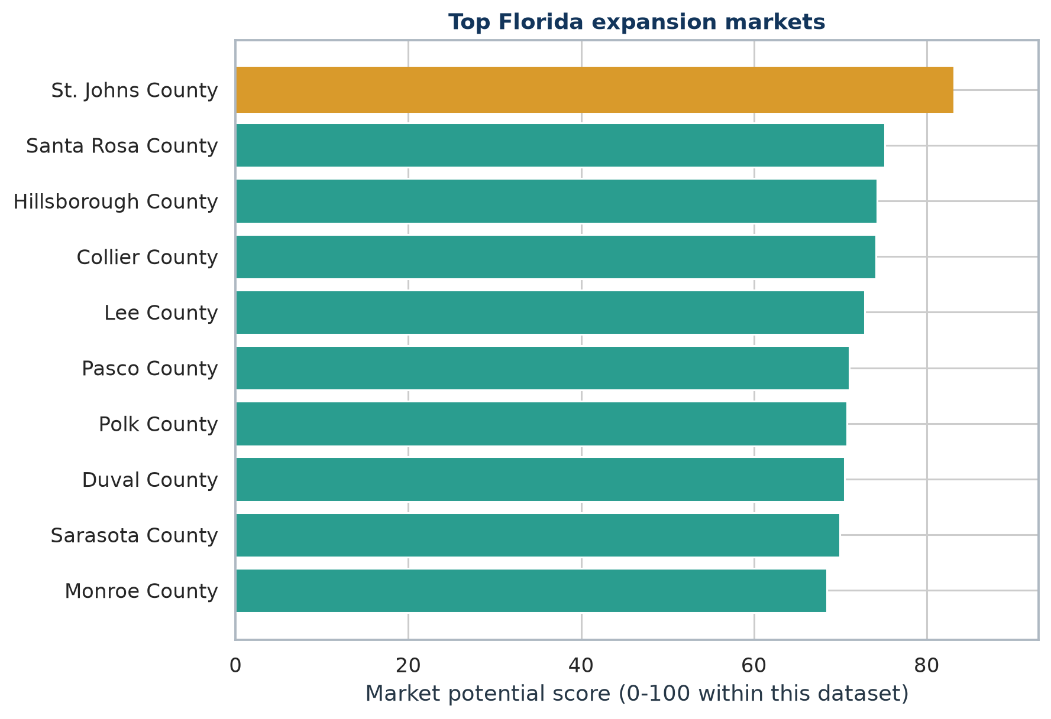
Figure 5. Top ten Florida counties by the current market-potential score.

1. St. Johns County | Score 82.9/100. Key screening strengths: favorable purchasing power, LA Fitness whitespace, light tracked-competitor intensity. Observed LA Fitness locations: 0; tracked competitors: 4.
Score 82.9/100. Key screening strengths: favorable purchasing power, LA Fitness whitespace, light tracked-competitor intensity. Observed LA Fitness locations: 0; tracked competitors: 4.

2. Santa Rosa County | Score 75.2/100. Key screening strengths: favorable purchasing power, LA Fitness whitespace, light tracked-competitor intensity. Observed LA Fitness locations: 0; tracked competitors: 1.
Score 75.2/100. Key screening strengths: favorable purchasing power, LA Fitness whitespace, light tracked-competitor intensity. Observed LA Fitness locations: 0; tracked competitors: 1.

3. Hillsborough County | Score 74.2/100. Key screening strengths: large demand base, existing market evidence. Observed LA Fitness locations: 7; tracked competitors: 18.
Score 74.2/100. Key screening strengths: large demand base, existing market evidence. Observed LA Fitness locations: 7; tracked competitors: 18.

4. Collier County | Score 74.1/100. Key screening strengths: favorable purchasing power, existing market evidence, light tracked-competitor intensity. Observed LA Fitness locations: 1; tracked competitors: 5.
Score 74.1/100. Key screening strengths: favorable purchasing power, existing market evidence, light tracked-competitor intensity. Observed LA Fitness locations: 1; tracked competitors: 5.

5. Lee County | Score 72.8/100. Key screening strengths: large demand base, existing market evidence. Observed LA Fitness locations: 2; tracked competitors: 10.
Score 72.8/100. Key screening strengths: large demand base, existing market evidence. Observed LA Fitness locations: 2; tracked competitors: 10.

Recommended Next Actions
- Validate current club rosters, closures, planned openings, and public price offers in the top five counties.
- Collect observed monthly dues, initiation fees, annual fees, promotions, and contract terms for a representative sample of clubs.
- Replace county boundaries with 10- to 15-minute drive-time trade areas around candidate sites.
- Add lease rates, daytime population, age mix, traffic counts, and competitor square footage before site underwriting.
- Re-estimate the model with broader observed comparable prices and validate out of sample before using it for capital allocation.

Limitations
- Price target coverage: 32 counties use local official advertised offers; 35 use the transparent statewide median because no local public rate was available. The target is not a transaction-price survey.
- Search coverage: Google Places Text Search ranks candidates and does not guarantee a complete chain inventory.
- Temporal mismatch: demographics use 2020 population and 2021 income, while locations and prices are retrieval-time snapshots.
- Aggregation: county averages mask neighborhood trade areas and cross-county customer travel.
- Small sample: 67 counties limit model complexity and make influential observations consequential.
- Association only: OLS coefficients do not identify causal effects on pricing or expansion success.
- Ranking sensitivity: market-potential results depend on subjective weights, min-max scaling, and the observed-versus-estimated price mix.

Reproducibility and Deliverables
- scripts/fitness_market_analysis.py: API collection, official-price integration, EDA, regression, diagnostics, predictions, and rankings.
- data/MainDataset.csv: 67 rows and 8 required columns, rebuilt from the current observed/estimated price target.
- outputs/: model tables, diagnostic tables, pricing-coverage audit, scenario predictions, rankings, and current figures.
- API key files are read locally and intentionally excluded from every analytical output.

References
U.S. Census Bureau. 2020 Census Redistricting Data, Table P1, variable P1_001N. Source
U.S. Census Bureau. 2021 ACS 5-Year Estimates, Table B19013, median household income. Source
U.S. Census Bureau. 2020 Gazetteer Files and record layout. Source
Google Maps Platform. Text Search (New) documentation and pagination requirements. Source
LA Fitness. Public online membership rate example with monthly plan options. Source
Planet Fitness. Official membership page with starting monthly rates. Source
Health & Fitness Association. U.S. facility membership and average-dues overview. Source

